Assignment 6 – Optimizing Island Problem

Here is the picture representing the problem we are trying to solve:

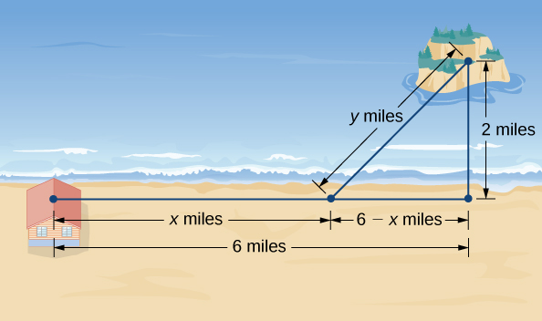

Figure

Description:

An island is 2mi due north of its closest point along a straight shoreline. A visitor is staying at a cabin on the shore that is 6mi west of that point. The visitor is planning to go from the cabin to the island. Suppose the visitor runs at a rate of 8mph and swims at a rate of 3mph. How far should the visitor run before swimming to minimize the time it takes to reach the island?

**Operation:**

* The problem is asking us how far the visitor should run on the shore before swimming to the island in order to get their as fast as possible
* When you load the program and select “Optimize the problem,” a summary of what is being solved will be displayed
* For the left extents, it needs to be over 0 because time is not negative. For the right extent, you’d put whatever you want
* It will then show a graph that explains the different walking and swimming times and when the fastest will be

**Specifications:**

* Data Element: Same as Lab 10 & 11
* Data Structure: Very much the same as Lab 11. However, there is a bit more of a difference in which there is an x and y that is being used, z is not being used. For x, it is the distance that the visitor needs to run and the y refers to the distance that the visitor needs to spend swimming to the island, both distances in miles. The result is the amount of time that it will take in order to get to the island in hours.
* Data Manager: Same As Lab 10 & 11
* GUI Driver:
  + When the GUI is loaded, you get an exit button and an “Optimize the problem” button.
  + When optimize is pressed, a JavaFX alert is opened tells the user the description of the problem
  + The left and right extents are asked, (Domain of the graph)
  + GUI creates a graph showing only the domain that the user input, will show the optimized problem.
  + This process can be repeated

**Findings**:

Initially, I had to figure out how to optimize. We will use the variables Tr and Ts, for time running and time swimming respectively. We will use x as the distance running and y for the distance swimming, which his what we’re looking for to get the fastest time In order to get the total amount of time, T, we need to combine the two: Tr + Ts. Time is calculated as Distance over rate. So, if we put that into terms of the problem, Tr = x / 8 and Ts = y / 3, making T = x /8 + y / 3. We need to put this in terms of one variable, x. We can use the Pythagorean theorem in order to find y, the hypotenuse in Figure 1. We get 2^2 + (6-x)^2 = y^2. Simplifying that, we get y = sqrt( ( 6 – x ) ^ 2 + 4) Substituting that in, we get T = x / 8 + (sqrt( ( 6 – x ) ^ 2 + 4) / 3. That’s what you use for fnValue. For getY, you use what we found for y earlier, sqrt( ( 6 – x ) ^ 2 + 4. In the end, you see that it takes 1.37 hours to get to the island, running 5.19 miles on shore, and swimming 2.16 miles. 1.37 hours is the fastest that you can get there.